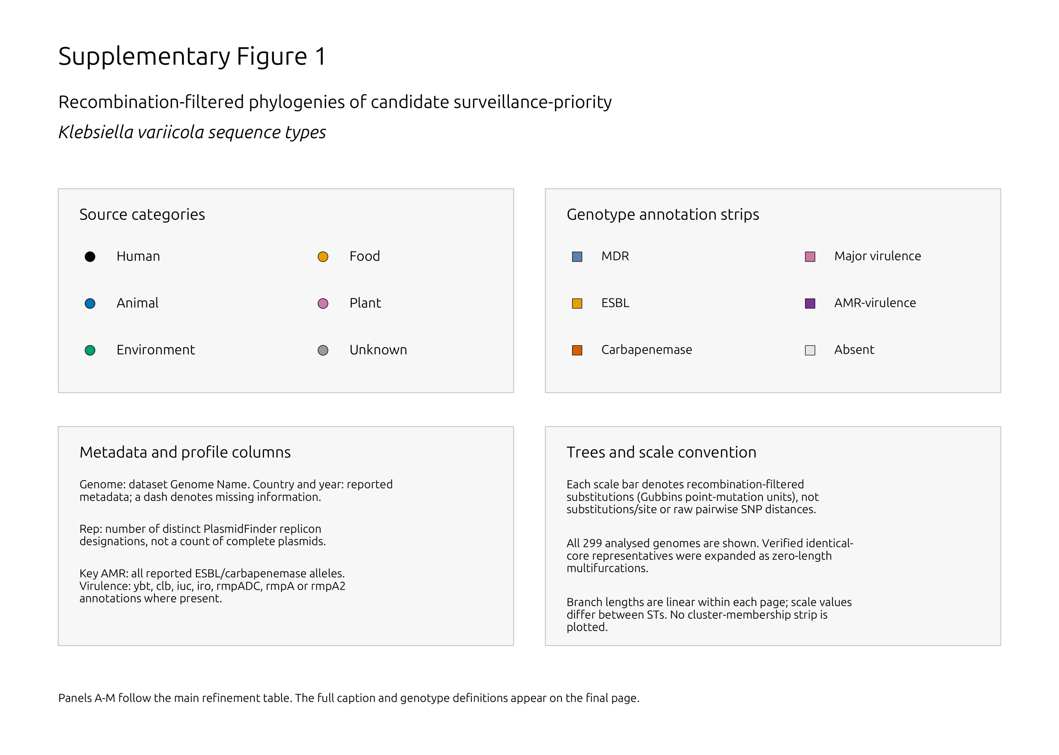

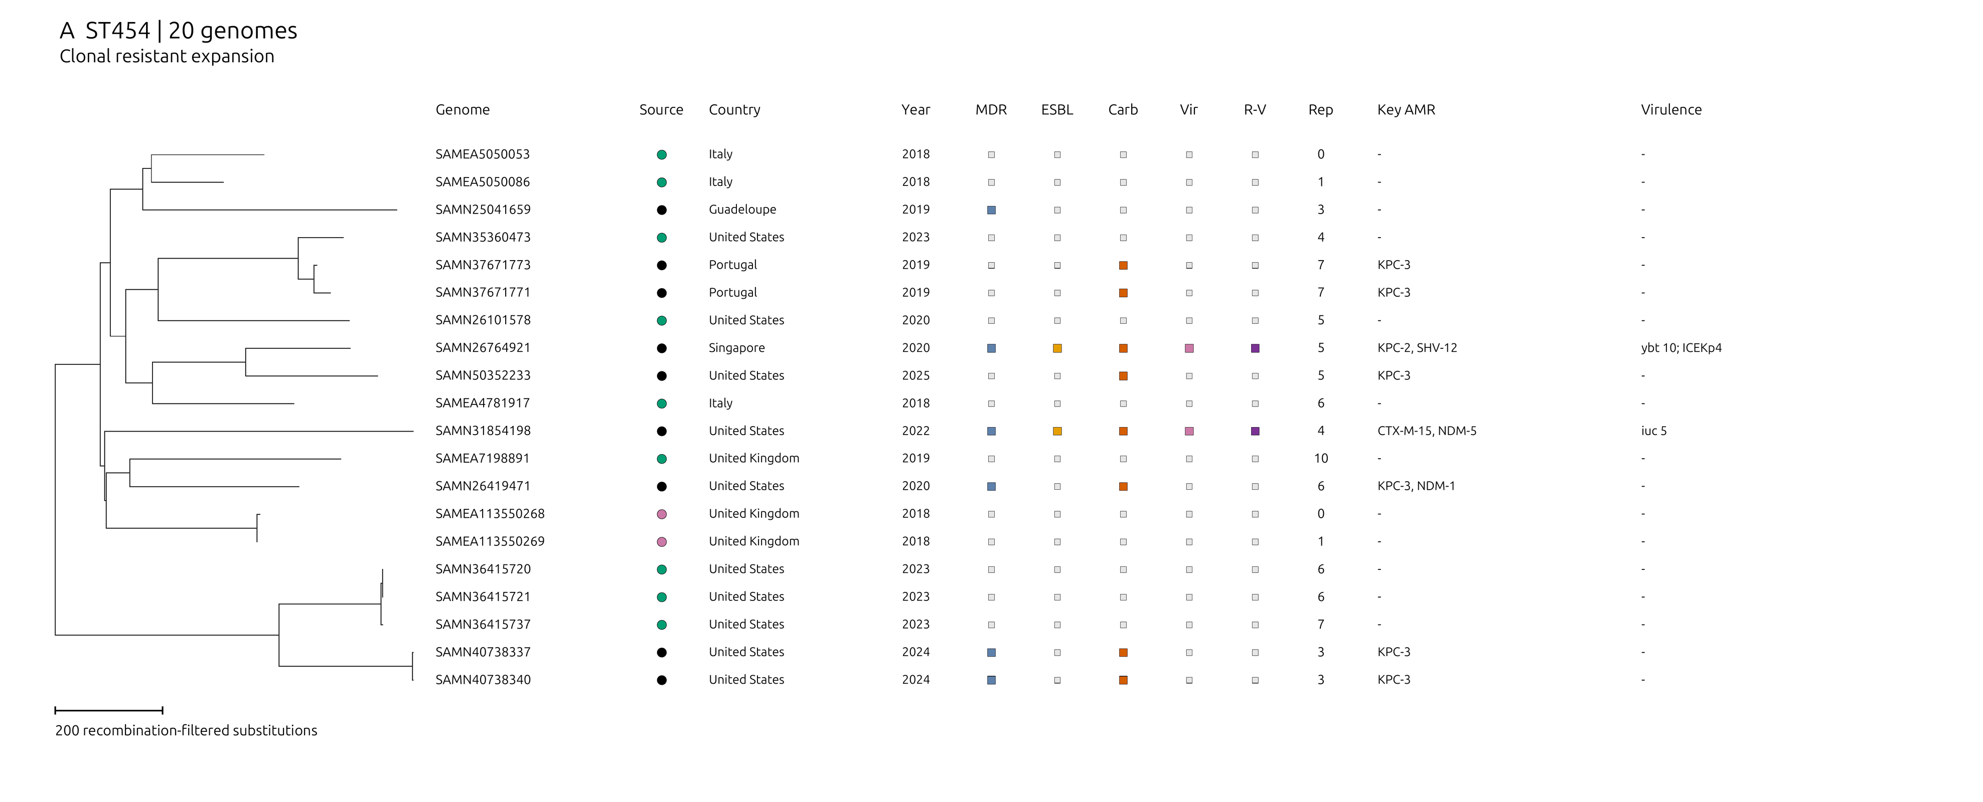

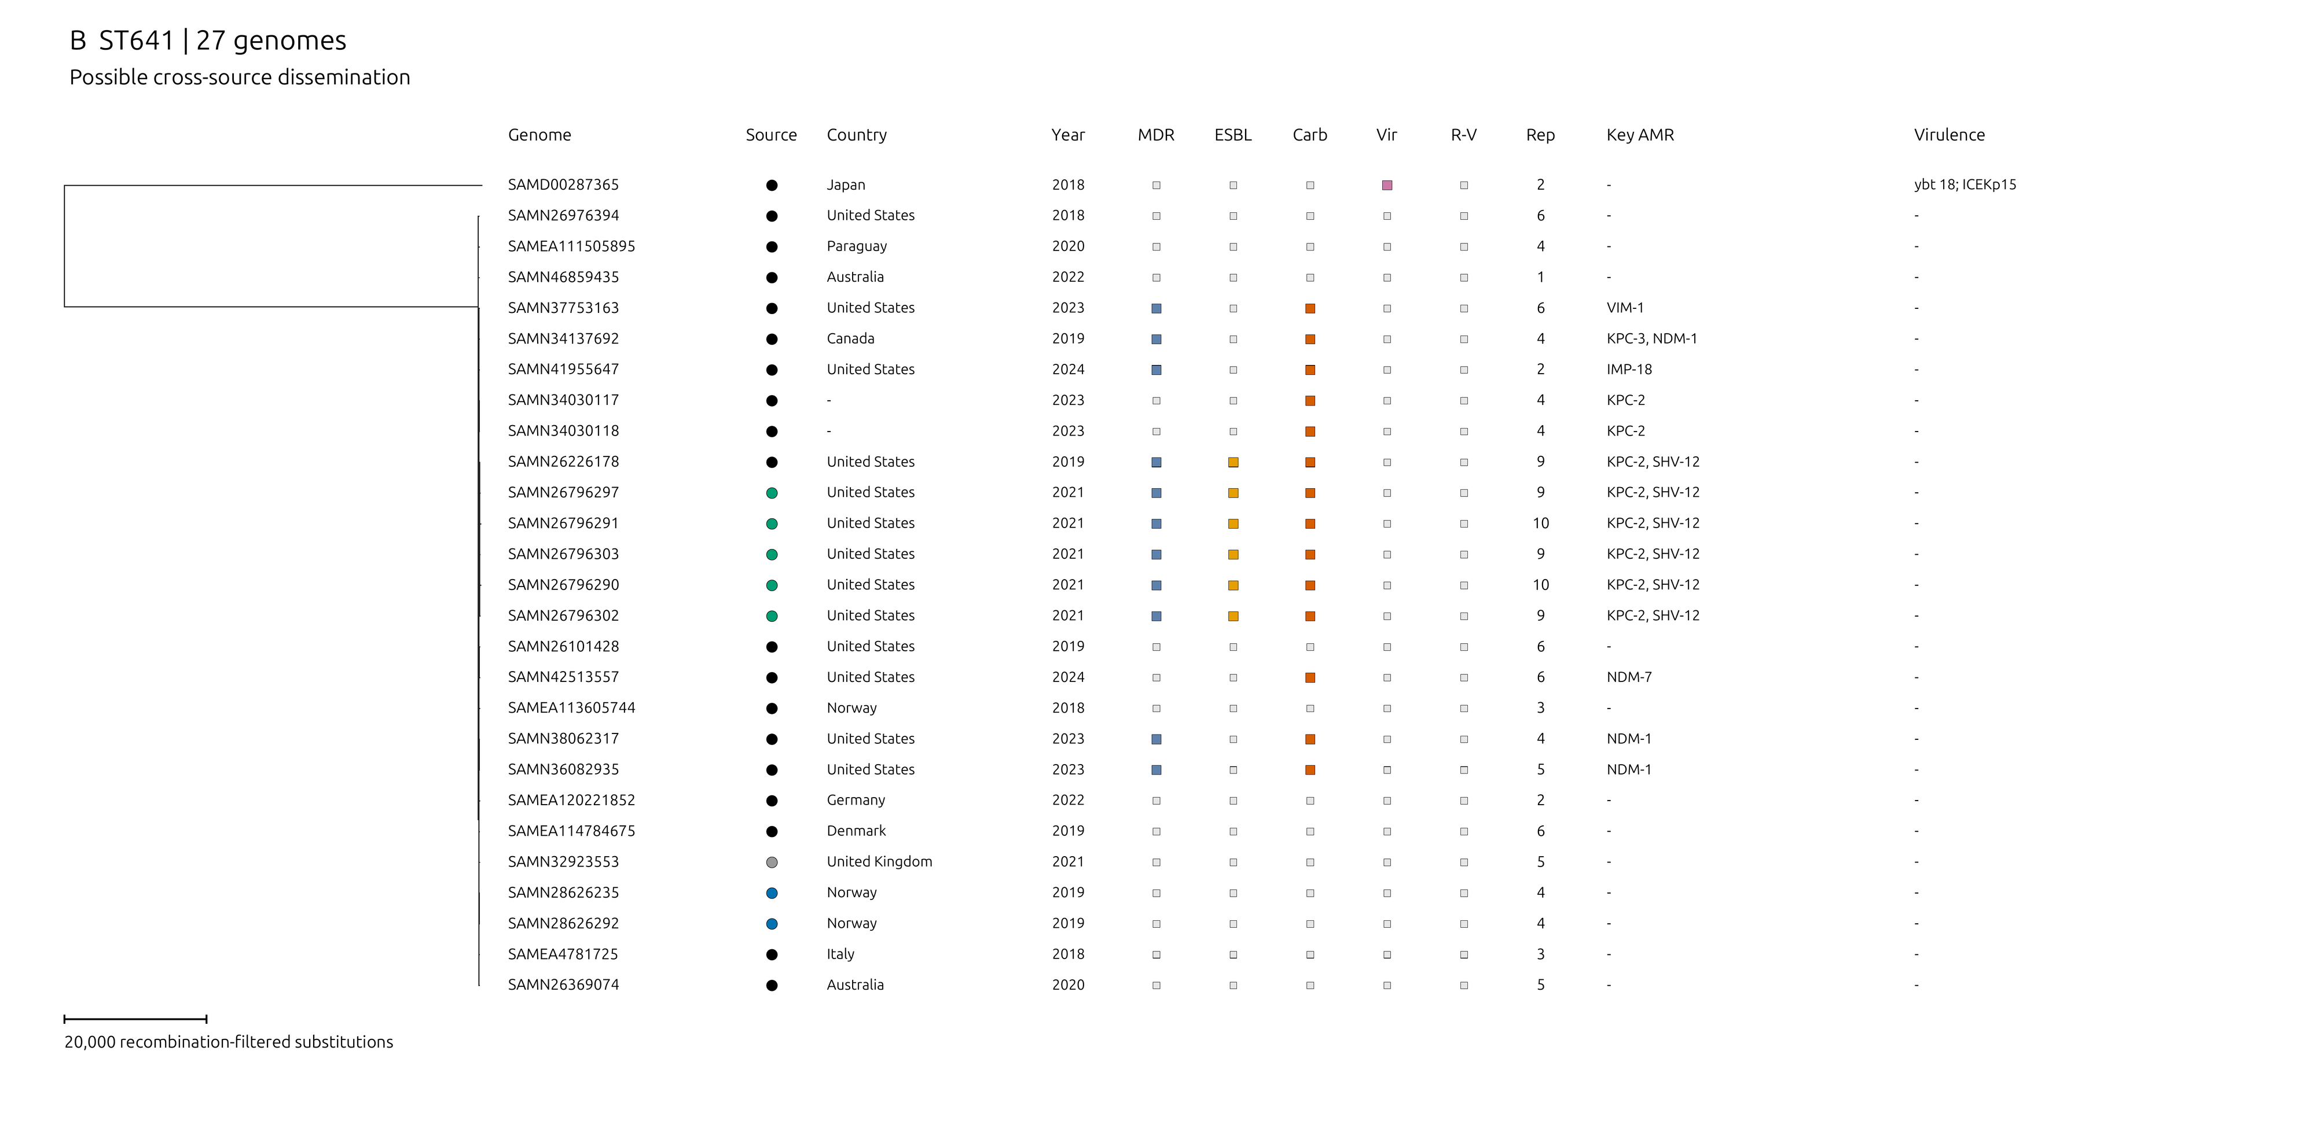

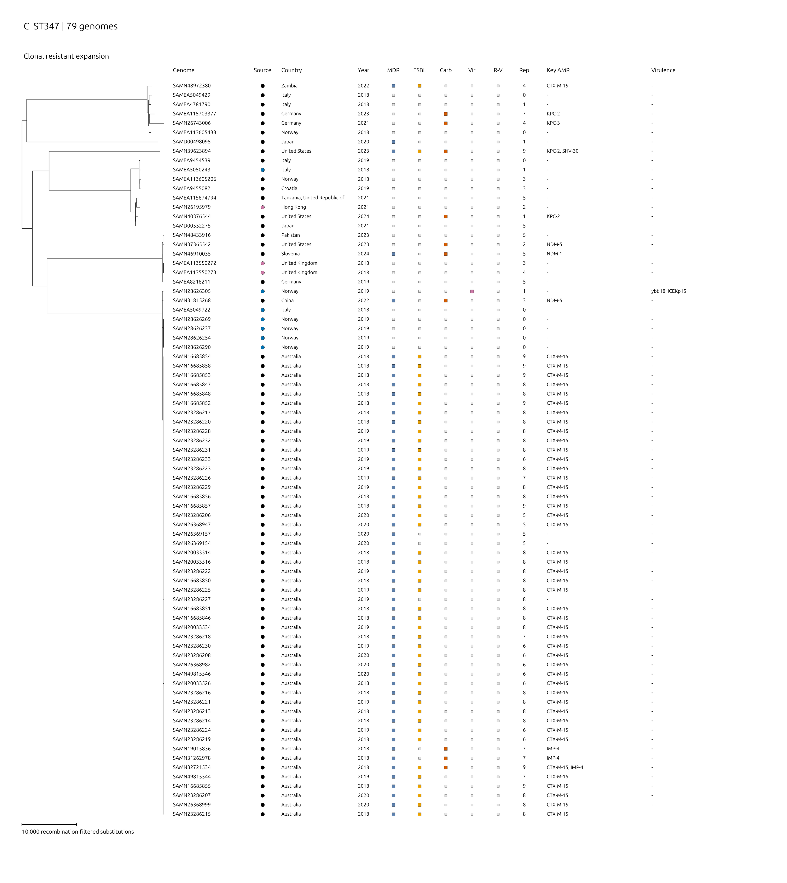

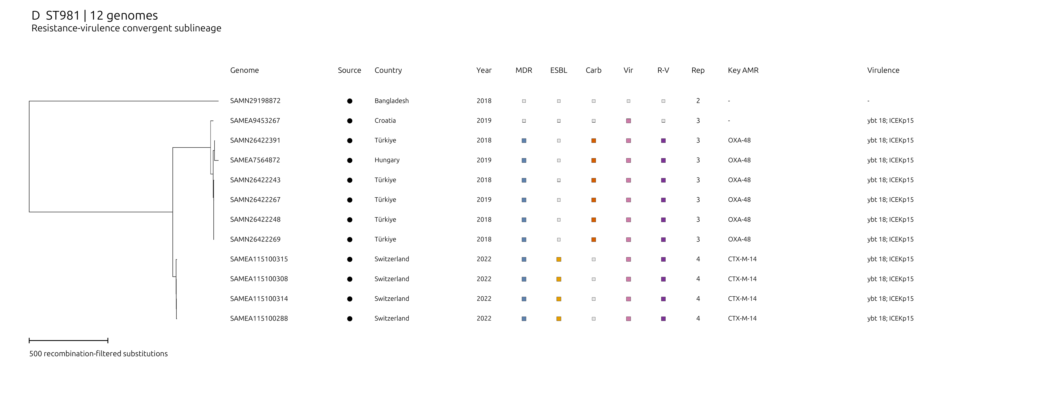

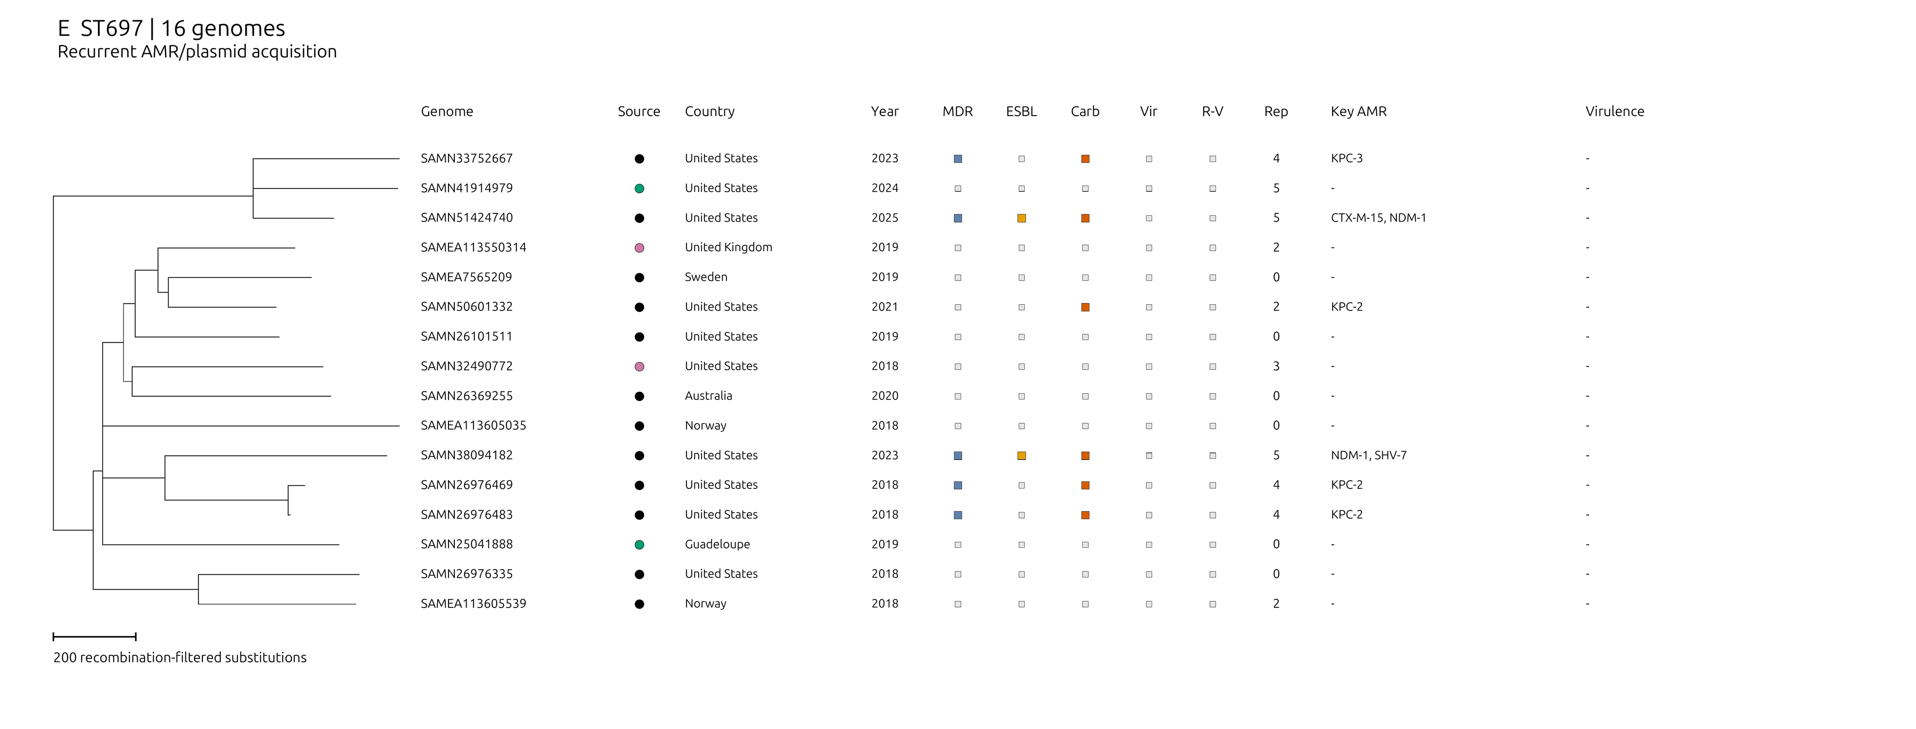

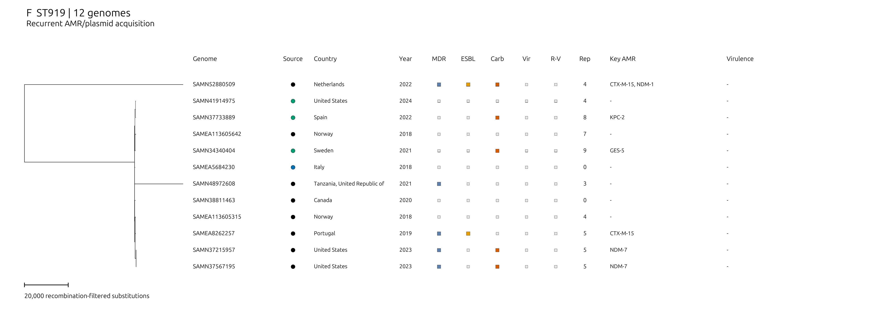

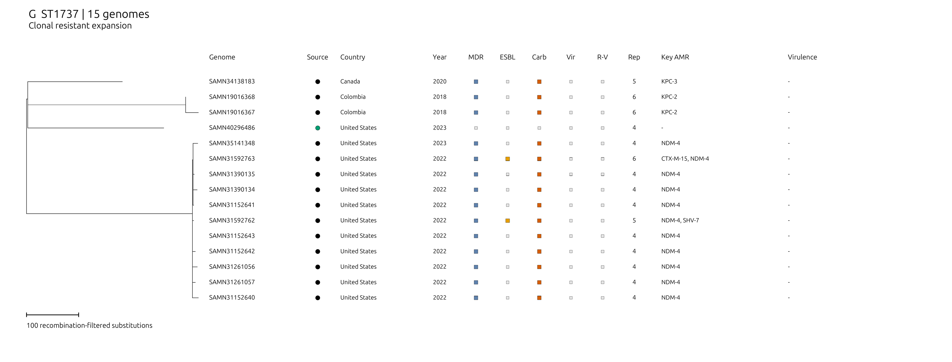

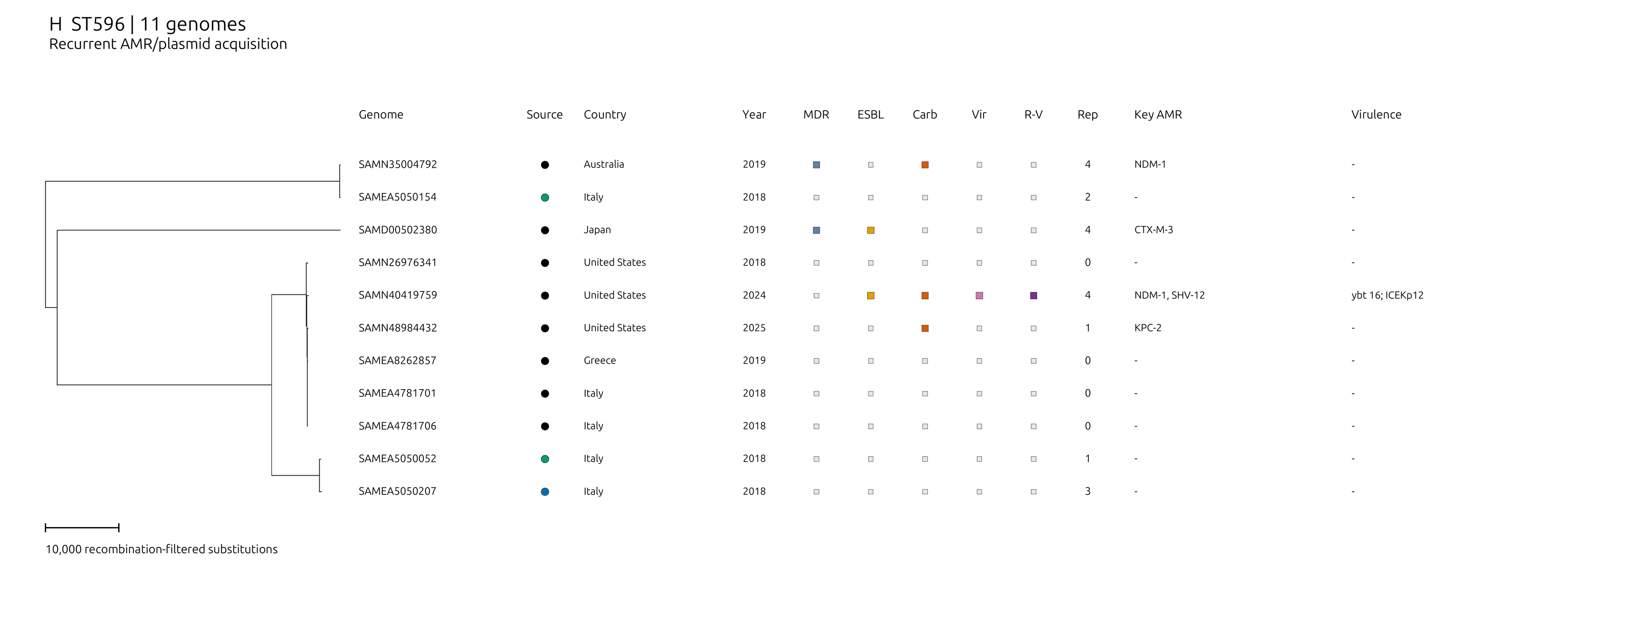

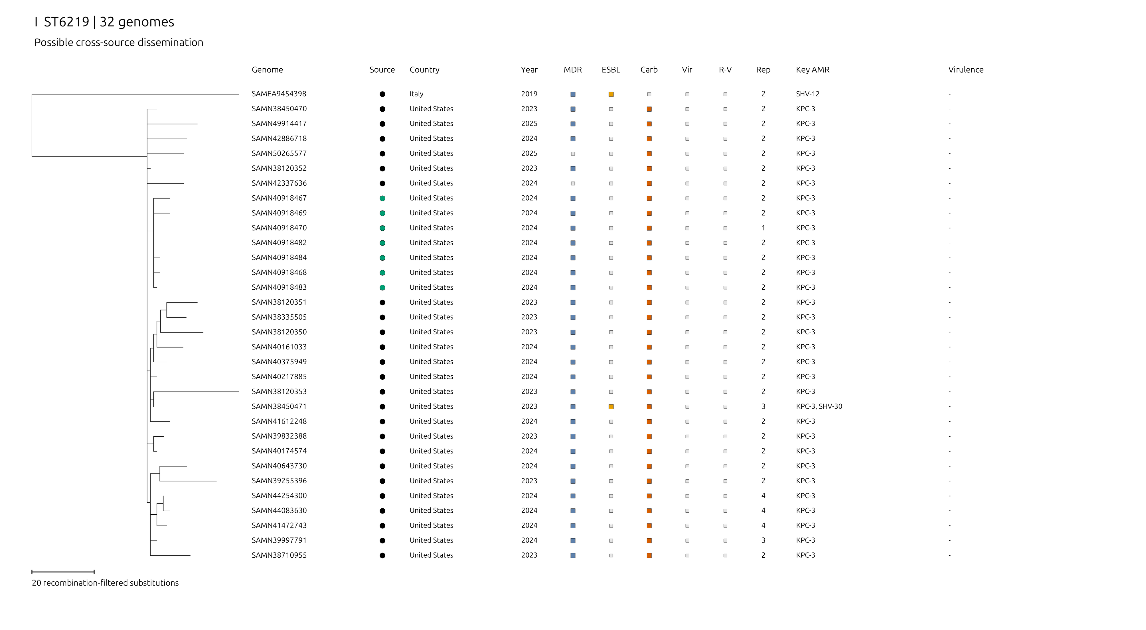

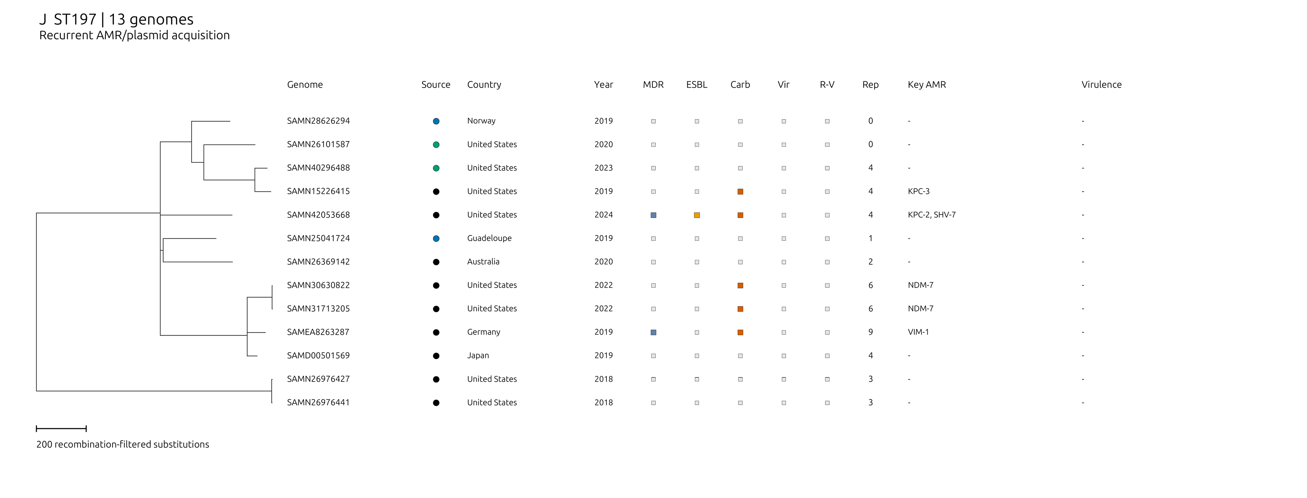

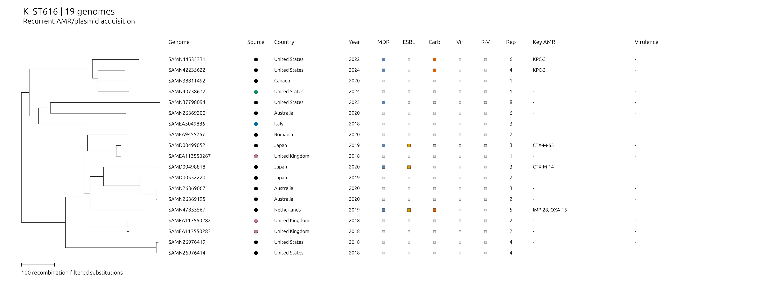

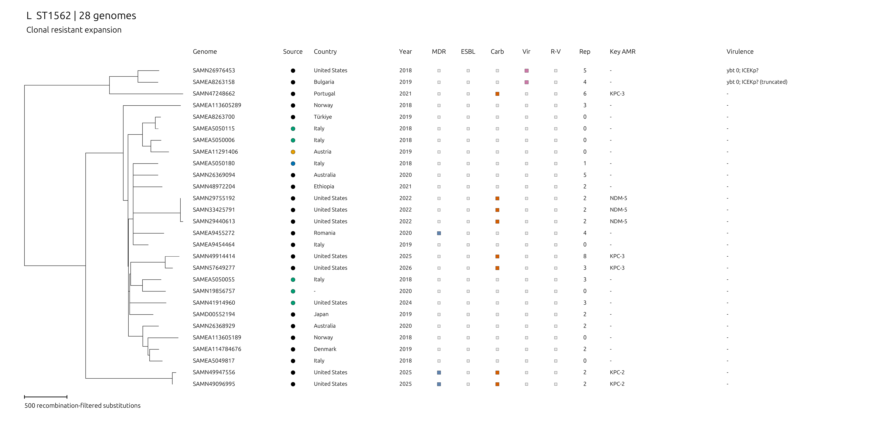

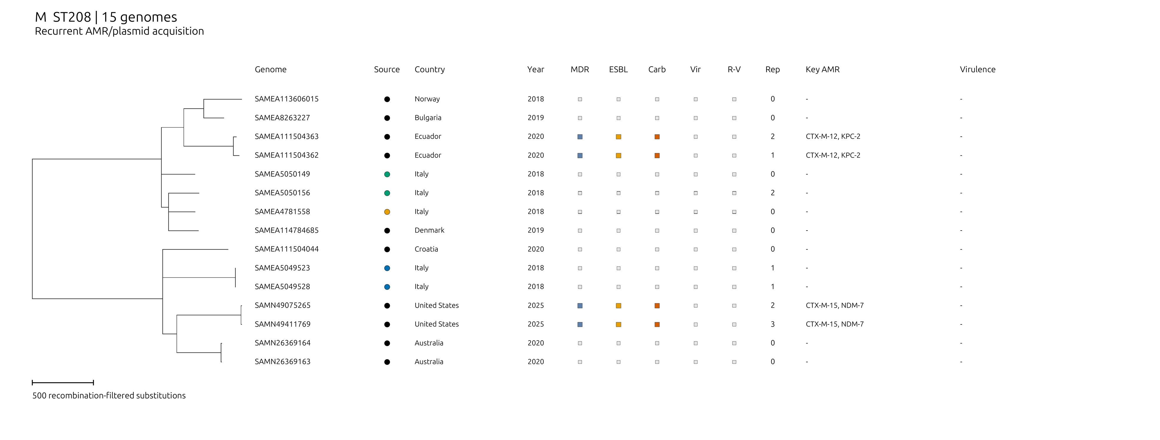

Supplementary Figure 1. Recombination-filtered phylogenies of candidate surveillance-priority Klebsiella variicola sequence types.
Panels A-M show ST454, ST641, ST347, ST981, ST697, ST919, ST1737, ST596, ST6219, ST197, ST616, ST1562 and ST208, respectively. The trees include all 299 candidate genomes represented in the recombination-filtered alignments. SAMN26369047 was not included in the ST1562 phylogeny following its earlier exclusion for assembly fragmentation; it remains among the 300 genomes used for ST-level prioritisation. Removed population-QC genomes are not shown. Verified identical core-alignment sequences were restored at zero branch length around their representative, without resolving relationships among indistinguishable tips.
Branch lengths and individual scale bars denote recombination-filtered substitutions in Gubbins point-mutation units, not substitutions per site. These inferred branch lengths are distinct from the observed pairwise SNP counts used for clustering. Scale values differ among panels; each tree is drawn on a linear scale. Root placement follows the retained tree and is not evidence of the direction of spread.
Tip metadata show source category, country, collection year, genotypic MDR, ESBL, carbapenemase, major virulence markers, AMR-virulence convergence and the number of distinct PlasmidFinder replicon designations. MDR denotes an exported resistance-class count of at least three; these reporting categories include separate beta-lactam categories and do not establish phenotypic MDR. ESBL denotes a hit in either acquired ESBL field, including the inhibitor-resistant ESBL field; carbapenemase denotes an acquired carbapenemase hit. Vir denotes a reported yersiniabactin (ybt), colibactin (clb), aerobactin (iuc), salmochelin (iro), rmpADC, rmpA or rmpA2 annotation. R-V denotes co-carriage of a major virulence marker and MDR, ESBL or carbapenemase status. These annotations do not establish locus functionality or hypervirulence.
Key AMR lists ESBL/carbapenemase alleles; the virulence column gives reported locus annotations. Grey squares indicate feature absence, grey source circles indicate unknown source, and dashes denote missing metadata or no detected gene/locus in the corresponding column. Cluster membership is supplied in the accompanying tables rather than plotted as a separate strip. These within-ST phylogenies refined surveillance prioritisation by assessing resistant expansion, possible cross-source and international clustering, resistance-virulence convergence and dispersed resistance compatible with acquisition or loss. Categories are descriptive and non-exclusive. Close ancestry and matching genomic profiles do not demonstrate direct transmission, independent acquisition events, intact plasmid structures or AMR-gene localisation.

